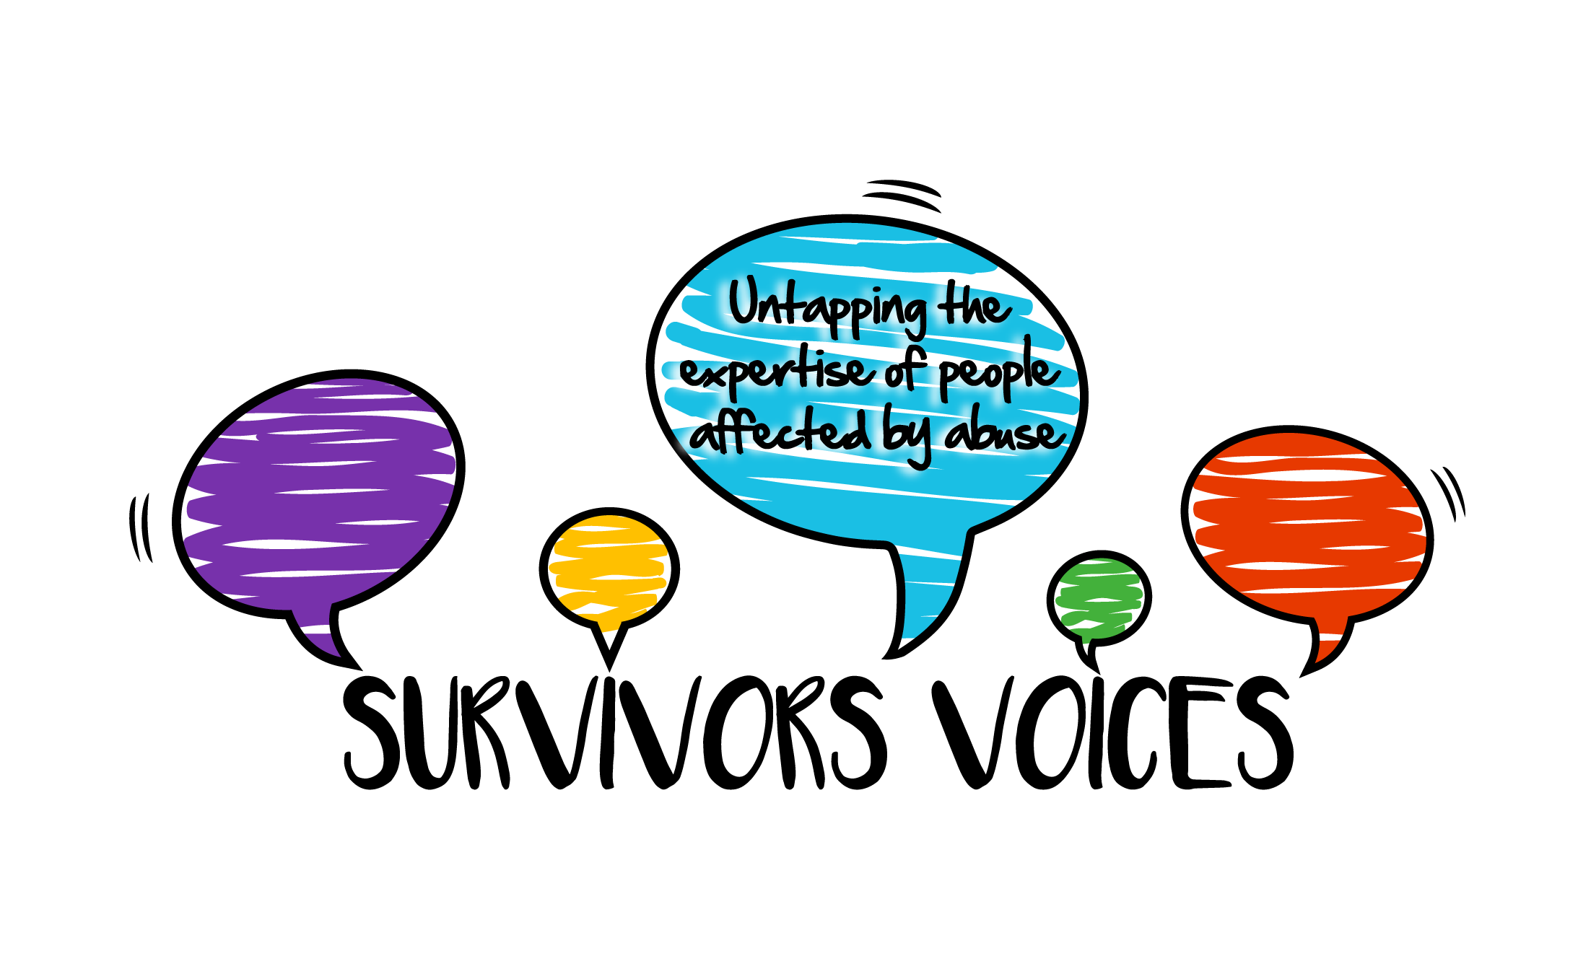
Survivors Voices Linking Service

If you are working on a research study and are seeking researchers to co-produce the project, be part of a Lived Experience Advisory Group (LEAG) or are looking for participants to interview, our Linking Service is available to assist you.

Survivors’ Voices have a community of around 600 abuse survivors and a contact list of 2400+, some of whom may wish to participate in your study.

If you choose to engage in the Linking Service, Survivors’ Voices will wish to check that your project offers participants safety and good and ethical survivor participation. Most of these requirements will probably have been covered in your ethics application.

Survivors’ Voices asks you to confirm these criteria are embedded in your study:
- You have read and commit to the principles in the Survivor’s Voices Charter for good survivor involvement (https://survivorsvoices.org/charter/)
- The study has engaged in co-production to at least level 3 (survivors as advisors) of the Survivor Involvement in the Involvement Ladder (https://survivorsvoices.org/involvement-ladder/)
- Participants’ time and contribution will be recognised with appropriate recompense.
- You will offer active support for all participants who wish it, more than just a list of helplines.
- You will recruit carefully and sensitively, signposting anyone excluded to other opportunities (e.g. our activist community).
- You have thought about how to reach under-represented groups.
- You have access to support yourself, which can include our Researcher Community.

The Linking Service offers the following:
  - A review of your application, with constructive feedback where appropriate, with the aim to provide assurance that your project meets the criteria of the Survivors’ Voices Charter.
  - A space on the website to share recruitment information (see here).
  - Listing in our monthly mailings to potential participants (2,000+ agencies & individuals, and 600+ abuse survivor members), and social media channels (Instagram, LinkedIn, X, Facebook).
  - Introductions to other groups and agencies that may assist with recruitment from particular communities and under-represented groups.
  - Peer support communities are also available for both survivor researcher(s) and participants, including the Researcher Community and Changemakers Community.
  - Findings can also be shared in these groups and in our mailings.
  - A comprehensive curated list of sources of further support for participants and survivor researchers.

The following charges apply:
- Universities: £650
- Charities/not-for-profits: £325
- Individuals (e.g. students): £150

If your project is unfunded and you cannot meet these costs please be in touch; we can discuss an appropriate sum for the linking service. We encourage you to explore possible funding sources for supporting PPI/lived experience involvement.

To apply for the Linking Service, please complete the form below, and send to research@survivorsvoices.org with any supporting evidence. We will be in touch with any questions and to make arrangements to publicise your study, if accepted. We can also offer advice and support to meet our criteria, and access to a lived experience consultant to assist with lived experience advisory groups, active recruitment, and peer support for participants and researchers. Please contact us for further details of services and fees.

Survivors’ Voices Linking Service Application Form
Your Name
University/organisation
Role
Name of Research Study
Has your study already received ethical approval? (if yes please provide reference details and number). |  | Tick
1. Please provide a 1-page summary of the research project e.g. Participant information form and consent form.
2. Please describe how the study has engaged in co-production to at least level 3 (survivors as advisors) of the Survivor Involvement in Research Ladder (https://survivorsvoices.org/involvement-ladder/) i.e. people with lived experience have, at a minimum, been consulted regarding study design, or participant participation. This can include your own lived experience, if relevant.
3. Please confirm that the study design includes pre- and post-study support for participants (as individually required) and provide details of the support offered. We require that the researcher should discuss with potential participants who they will contact in the event of the need for post-interview debriefing and/or support. This might be with the researcher, a known mental health worker, a GP, or a peer support network. The researcher must send a follow up email/call to check if support is wanted by the participant, and if it is being taken up. The wishes of the participant are paramount, and agency should rest with the participant.
4. Please confirm that you also provide a list of relevant support lines and/or agencies. This should include emergency/immediate help and ongoing support. All links and numbers must have been checked to ensure services are available in a timely manner should a survivor reach out for support in this way. The Survivors’ Voices peer support network can be included in the list, but should not be the only post-interview support available. We can provide a list of agencies you can consider for inclusion.
5. Please describe how survivors will be reimbursed for their contribution to your study.
6. Please describe how you plan to reach out to under-represented groups, as appropriate. We can help by connecting you with specialist agencies and contacts we have in marginalised communities.
7 Please provide an indication/example of how you would respond to people you decided not to include in your study. Recommend you consider signposting to other relevant opportunities; this can include Changemakers, our activist community.
8. Please explain how you will deal with any safeguarding issues that might be disclosed in the course of the research. We expect you to follow any organisational policy in a way that leaves as much agency and choice as possible with the survivor.
9. Please explain what support you have available for the impact this type of research may have on you, especially if you are someone with lived experience. This can include membership of our Survivor Researcher community, if you identify as a survivor.
10. Please confirm that you have read and commit to follow the principles in Survivor’s Voices Charter for good survivor involvement.
Is there anything else you would like us to know?

Please send this form when completed to research@survivorsvoices.org, along with any supporting evidence and your contact details. We will review your information within two weeks, and may request further information.

Once we have confirmed that your study meets our criteria, we will need:
- Word text advertising your study for our newsletter and website. You can also include a graphic as a .jpg or .png. Or a single ‘infographic’ style advert, which also needs to be a .jpg or .png. Maximum word count 250 words. Please include your email or the link for further information. We can include links to downloads and/or videos on the website if desired.
- Text and/or images for social media posts, along with any design elements pre-approved with ethics. We will use these to create social media posts for Instagram, X, Facebook and Linked-in. Please include your social media handles so we can tag you.
- Details of who to invoice, purchase order number and any supplier approval process required.

We will aim to have information posted within two weeks, depending on how much editing and design is required. We will check any drafts with you before posting. We will pass your contact details on to our social media associate, who will be in touch about communications and website entries.

Please do be in touch if anything is unclear, or there is anything you’d like to discuss.

Survivors Voices Researcher Community Team, 2025.

